
Caring for your New
Edenstone Home

Handy hints and tips to look after your new property

Welcome to your new Edenstone home

Moving into a new home is always an exciting time – there’s so much to discover and explore. We at Edenstone Homes take great pride in ensuring that your new home doesn’t just live up to these expectations, but exceeds them. To help keep your new home in tip-top condition we’ve prepared this booklet full of handy hints and tips. This advice will help you enjoy your new home to the full.

The advice given here will certainly help you get the most from your property. However, should you have any queries, or require assistance please do not hesitate to contact us. We want you to be as happy with your Edenstone Homes home in the years to come as you were the day you bought it!

Also, please refer to the 2 year builder’s warranty ‘First Two Years at a Glance’ sheet.

Any questions please contact the Customer Care Department; we are here to help!

Please note:

The hints and tips in this booklet are a general guide to looking after your home. As a result, the advice given may not be appropriate in every circumstance. Whatever type of property you have, it’s important not to attempt any repairs or maintenance work that you may think is too difficult for you, or which might put you at risk. For example, repairs to your electrical and plumbing systems should only be carried out be qualified professionals.

Index

Page
- Drying Out/Shrinkage 3
- Condensation 3
- Hot Water and Heating System 4
- Plumbing 5
- Baths and Showers 5
- Toilets 5
- Gas 6
- Kitchen Units and Worktops 6
- Kitchen Appliances 7
- Smoke Alarms 7
- Sprinkler Systems 7
- Lighting 7
- Trip Switches/Consumer Unit 8
- Everyday Electrical Safety 8
- Internal Doors and Fire Doors 8
- Loft Space 9
- Drainage Access 9
- Garages 9
- External Timber 10
- Windows 10
- Driveways 10
- External Render 11
- Efflorescence 11
- Gutters 11
- Outside Tap 12
- Lawns and Plants 12
- Communal Areas 12
- Storms 13
- Standard of Finish 13
- Water Meter 13
- Maintenance of Fitted Flooring 13
- Contact Numbers 14
- 2 Year Warranty at a Glance 15

- Drying Out/Shrinkage 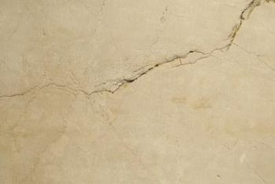

It sounds incredible, but did you know several thousand litres of water went into making your new Edenstone Homes home?

Over time this water will dry out naturally as your home is lived in and heated. This may cause timber and other materials to shrink a little, small cracks and plaster “pops” may occur on your walls and ceilings. A plaster pop is when the plaster falls away from the head of the fixing, showing as a bulge of plaster or leaving the head clearly visible. Although a little annoying these faults can be soon put right with a few minutes of DIY and are, therefore, not covered under our warranty.

To keep such cracking in your new home to a minimum, try to maintain a reasonably low and constant temperature throughout your house, even in rooms which aren’t occupied. You should also try and ventilate as much as you can by leaving windows, doors and trickle vents open. This will allow moisture to evaporate.

- Condensation 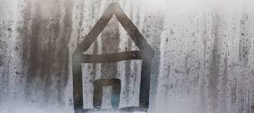

Condensation is likely to occur in all new homes, as the moisture in the structure starts to dry out. This, combined with the moisture produced by everyday activities such as cooking, ironing and showering, may cause condensation to appear on the cold surfaces within your home such as windows, external walls and cisterns. If allowed to persist, it can sometimes cause mould on walls and ceilings.

To reduce this, you should:

- Cover pans and switch off kettles after they boil and dry clothes outdoors wherever possible
- Opening windows for a while each day, even in winter, to allow a change of air and ensuring that vents are open and not blocked
- Ensure there is adequate air flow behind furniture, pictures etc.
- Wiping down surfaces when moisture settles
- Maintaining low background heat
- Using the extractor fans where provided in bathrooms, en-suites and kitchens and do not switch off isolators

- Hot Water and Heating System 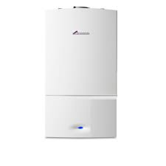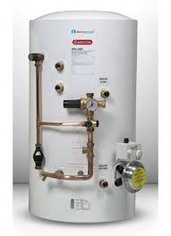

In line with the manufacturer’s recommendations, your central heating boiler and, if applicable, pressurised cylinder, must be serviced annually by a Gas Safe registered engineer. It is vital to remember to arrange this service as your warranty WILL BE INVALIDATED if you don’t.

Combination Boilers: If the system loses pressure the boiler will not ignite and you will need to re-pressurise. Following the manufacturer’s guide, connect the filler loop between the valves under the boiler. Open the valves and allow the pressure gauge to reset to between 1 and 2 bar pressure. Isolate and disconnect the filling loop.

Boiler with Cylinder: Similarly, if there is a loss of pressure the boiler will not ignite and you will need to re-pressurise. Following the manufacture’s guide, connect the filler loop between the valves on the heating systems and the water supply to the cylinder. Open the valves and allow the pressure gauge to reset to between 1 and 2 bar pressure. Isolate and disconnect the filling loop.

If your radiators feel colder at the top than the bottom you may have to bleed the air from them. You’ll have been shown how to do this at the New Home Demonstration, but here’s a brief reminder:

Make sure the system is turned off and has chance to cool down. Then, slowly open the top side radiator valve just a small amount anti-clockwise with a radiator key and listen for the hiss of escaping air. Hold a cloth under the valve and catch the water as the last of the air is released. Then close the valve, but be careful not to over tighten the valve as it could break off inside the radiator. Once this is done you may need to re-pressurise the system as described above.

If you have a water cylinder the law requires a stored hot water temperature of 55-60°C degrees. This means the water from your hot taps can be very hot indeed, so please do take care. Please note, however, that in some areas the hot tap on the bath will have a temperature regulator fitted.

Dual Zone Heating: If your property is provided with a dual-zone heating system then you will have two controlling thermostats in your home. The lower thermostat will control the ground floor rooms and the upper thermostat will provide the same for all other rooms in the property.

- Plumbing 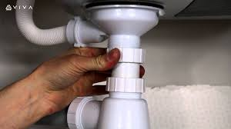

It’s always a good idea to check the water and waste connection to appliances and sinks after the first day or two of use as they can become loose and a dripping connection can cause a lot of damage!

- Baths and Showers 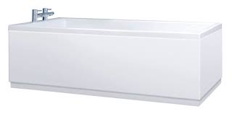

Please keep an eye on your bath and showers. As the property dries out the seal between them and the tiles may show a gap. Please re-seal or contact the Customer Care Department and we will be happy to assist you. However, please note that we are unable to assist with any damaged flooring caused by such gaps in the sealant not being re-sealed.

- Toilets 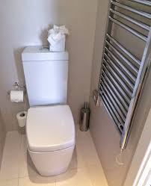

The cistern in your new home has been designed to meet new environmental guidelines and has a lower water content to reduce the amount of water wasted. This is the maximum size allowed in new properties and you may discover that this isn’t always as effective as larger cisterns found in older houses.

IMPORTANT: Do not flush nappies, wipes or sanitary items down the toilet of your new home as the system will not be able to deal with these items and it will likely result in an expensive blockage.

Most toilets now have an internal overflow which, if running, can be identified by water running into the toilet bowl when the toilet is not in use. This should be addressed to prevent unnecessary water wastage.

CLEANING: When cleaning the bowl of your toilet it is essential not to permit the cleaning materials to come in contact with the seat or stainless-steel hinges. If contact should occur inadvertently, the hinges should be immediately rinsed with fresh water and dried with a soft cloth. Prolonged contact with toilet cleaners could initiate a corrosion process which will become difficult to stop.

To clean the seat and hinges we recommend to use of warm water containing a few drops of washing-up liquid. This should be washed off with fresh water immediately afterwards and then dried with a soft cloth. Liquid Brasso will remove the pitting, but it may take a couple of attempts depending on how bad they are.

- Gas 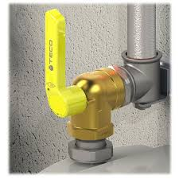

If you suspect a gas leak at any time of the day or night, you MUST take the following action:

- Turn off gas at the meter
- Call the gas emergency number – National Grid 0800 111 999

- Kitchen Units and Worktops 

It is a good idea to check hinges and drawer runners from time to time. Minor adjustments to realign the doors and drawers is a simple procedure, hinges can be adjusted for size, height and depth. We can supply simple instructions on request. When cleaning the fronts do not use excessive amounts of water or cleaners likely to scratch the surfaces.

Laminate worktops ‘whilst relatively hardwearing’ do need protection. Never place hot pans or dishes directly onto the tops, use a heat shield or pan stand. Similarly ensure a suitable cutting surface is placed on the worktops when using knives. Always wipe up spills immediately, not letting water stand on the worktops, especially around the sink or on joints. Water will penetrate these weaker spots and could lead to laminate damage. If possible, place small electrical appliances away from these joints as they could cause damage to these areas.

Granite surfaces can be easily cleaned and maintained using proprietary cleaners and polishes.

Stainless steel sinks should be cleaned of tea stains, grease and limescale daily, using a cream cleaner on a soft cloth. If brown spots appear in the sink’s surface they can be removed with a suitable cleaner. The sinks will inevitably become marked during use but these can be made less noticeable using a stainless-steel cleaner.

- Kitchen Appliances 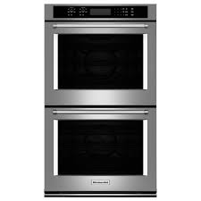

Please remember to register all your kitchen appliances, if there is a problem with one of them during the warranty period, simply call the manufacturer directly to arrange a home visit. You will find their phone number in the appliance handbook, however if the appliances are not registered you will need to have the model and serial number of the appliance to hand. You will find most serial numbers are printed on the inside of the appliance door.

- Smoke/Heat Alarms 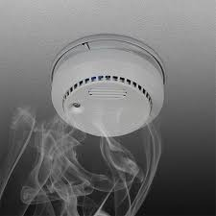

Every year in the UK hundreds of lives are saved by smoke alarms, and your Edenstone Homes home has been fitted with a least two alarms as standard. These alarms are mains operated with battery backup and you should check that they are working properly at least once a week by pressing the test button.

Periodic bleeping from your smoke alarms may indicate that your battery is about to run out and needs to be replaced. As an additional safety feature all smoke alarms in your new home are connected together so that if one is triggered, every alarm will sound a warning.

- Sprinkler Systems 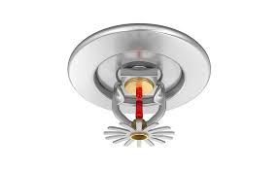

If your property has been fitted with a sprinkler system it is your responsibility to have the system serviced annually.

- Lighting 

You will find that some light fittings in your home are designed for use with energy efficient bulbs (they are cheaper to run!). Be sure to find out the type of bulbs needed and keep some spares. Please note that light bulbs aren’t covered by your warranty period, as these are classed as consumable items. Some Spot lights are a sealed LED unit and these can be changed by a competent person.

- Trip Switches/Consumer Unit 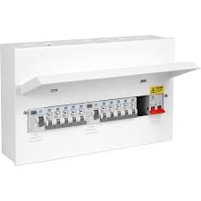

Modern electrical circuits are fitted with circuit breakers called trip switches. These are very sensitive but are there to ensure your safety. If a fault develops, a switch is tripped and the circuit is broken within the consumer unit. This will cause the electricity supply in different parts of your home to turn off e.g. lighting or power circuits. NB: It may be helpful to keep a torch in a suitable location.

The regular causes of tripped switches are:

- Blown light bulbs.

- Faulty or old appliances. If your sockets trip out you should first disconnect all appliances from the circuit, then reconnect them one by one to identify the failure.

- A circuit has been overloaded.

- Everyday Electrical Safety 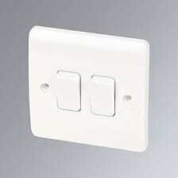

It goes without saying that all electrical alterations should be carried out by a qualified electrician. But you should also take care as you do DIY around your home not to damage any electrical cables that may be hidden behind walls or ceilings. It is a good idea to use a detector so you know exactly where your cables are.

- Fire Doors and Internal Doors 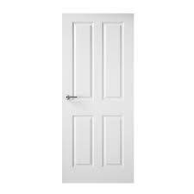
If you fit any new carpets, floor coverings or tiles you may need to arrange with your contractor for the bottom of the doors to be trimmed.

If you live in a three storey property or a bungalow, you will see that we include fire doors as a matter of course. These are heavier than standard internal doors and can help slow the spread of fire. For your own safety please do not leave fire doors propped open.

- Loft Space 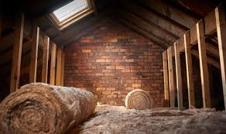

All the roof timbers in your loft are needed to support the roof. Don’t be tempted to cut and remove any of them!

It is also worth remembering that lofts aren’t really designed to be used as storage space. The extra weight of bulky stored items won’t have been taken into account during construction and your loft insulation will be compacted as a result, which in turn will hamper it’s effectiveness.

During the first few years in your new home, loft spaces are naturally prone to condensation. That’s why we recommend that you try not to use the loft too much and that the hatch is not left open for long periods. Ventilation is provided to control condensation, if vents have been provided in the eaves, take care not to block or cover them.

- Drainage Access 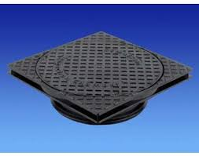

Planning the garden and outside areas of your new house is always fun. However, do take care that you don’t cover up any manhole covers or inspection chambers. In the unlikely event of a blocked drain or a leak, it is important that workmen have easy access to these points.

- Garages 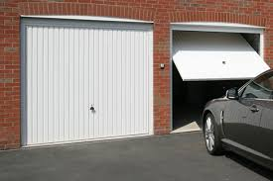

The outside walls of garages are often constructed from a single thickness of brickwork with central piers. This means that they may not be waterproof in all weather conditions, so we don’t recommend that you use this area for storage. In extreme weather some rain may be driven under the up and over doors.

It’s important to open and close the doors from a central position otherwise they may come off the runners and become unstable. Please maintain the working parts of the door in line with the manufacturer’s guidelines.

- External Timber 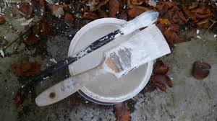

You should repaint or stain any outside woodwork, other than windows, after about 18 months. This will help to protect the timbers for about 5 years. However, if the wood is in an exposed area then you many need to repaint it as and when it is necessary. We would recommend that garden fences are treated with a preservative every two years.

- Windows 

UPVC: Window runner, handles and locking mechanisms should be regularly maintained in accordance with manufacturer’s instructions.

Timber Windows: Our timber windows are treated with a paint system that allows the timber to breathe. If your house is in an exposed area you should look for signs of minor cracking and peeling and touch up or repaint as necessary. As with UPVC you should maintain your window runners, handles and locking mechanisms.

- Driveways 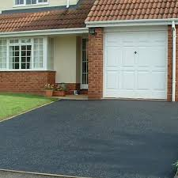

If your drive is finished with tarmac then it is important to remember that these surfaces are soft when laid and can soften again in hot weather. It will take many months for a new tarmac drive to reach full strength, so do take care not to place heavy weights on new driveways, eg. car jacks and skips etc.

You should also be aware that you can damage your driveway if your car has power steering. Tarmac drives will not withstand wheels turning whilst a vehicle is stationary, such actions can scuff the finished surface and even cause dents. To prolong the life and appearance of your drive, we recommend that you drive carefully and only turn when moving.

- External Render 

Over time some hair line cracking and crazing is likely to occur in external renders. However, such cracking or crazing will not impair the performance of the render and usually no repair is required.

In some instances, staining can occur on rendered finishes. The cause is likely to be the extended periods of damp/wet, warmer weather conditions experienced in recent times, encouraging the appearance of dirt and the subsequent development of an airborne species of algae. The staining is a known Europe-wide issue, as recognised by Material Manufacturers and Suppliers and does not have a detrimental effect on the structural integrity or weather tightness of the building.

Various cleaning products are available, an example being Weber CL150, which is a water-based masonry wash and steriliser. It can be used periodically as part of the Homeowner’s Maintenance Programme, based around local atmospheric conditions.

Moss and algae growth are a natural phenomenon and as such are deemed to be a household maintenance issue. NHBC do not consider it a defect as it does not breach Technical Regulation.

- Efflorescence 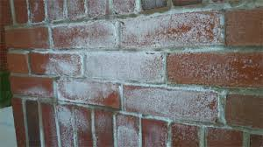

You may notice white marks appearing from time to time on your outer walls. This is known as efflorescence and is caused by the natural seepage of salts from the bricks and mortar. It can be easily removed with a stiff brush. However, over time the weather will reduce this naturally. Do not try to wash off the salts as this may make matters worse.

- Gutters 

Gutters should be cleaned out at least once a year to remove leaves and debris. Keep an eye out for wet patches on the wall below a gutter or downpipe, it could be a sign that it has become blocked and needs clearing. Please note that gutter damage caused by the weight of snow and ice is not covered under the warranty.

- Outside Tap 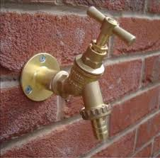

You must ensure that your outside tap, if fitted, is isolated internally before the winter to prevent freezing during the cold weather and prevent potentially serious leaks.

- Lawns and Plants 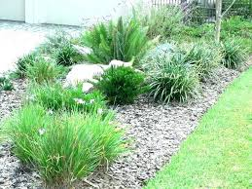

As gardeners know, keeping your lawn and plants in good condition does take effort.

Your turf is likely to only have been laid recently and therefore, during dry spells you must thoroughly water it every day until the turf is established. If the turf has not been watered properly there may be gaps appearing between the turfs and/or yellowing or browning of the grass. If this happens, just brush damp soil or sand into any cracks to prevent any further drying out and water.

It is essential not to walk on newly laid turf until it has become fully established, which is likely to take several weeks. Thereafter regular cutting is essential, with blades or rotas set high and then gradually lowered.

You should feed and weed your grass at least twice a year, usually between April and September.

For further information on looking after your lawn please go to the following link:

https://www.rhs.org.uk/lawns

Edenstone Homes do not guarantee the quality of your lawn after legal completion. Your lawn will need to be maintained and inspected by you to ensure it remains in good condition and free from pests. For example, in some areas of the country ‘Leather Jackets’ (Crane Fly lava) can severely damage a lawn as they feed on roots of the grass in your lawn.

For further information on Leather Jackets please go to the following link:

https://www.rhs.org.uk/biodiversity/leatherjackets

Many of our developments have a clay soil which can get waterlogged during rain, this can leave your grass in a poor condition. To alleviate this regularly aerate your garden with a fork or purpose made aerator, this will encourage the clay to breakdown and your soils to drain naturally.

Similarly, trees and shrubs will require regular watering to establish a healthy root system.

Ensure that tree ties, where fitted, are loosened off so that growth is not restricted. These can normally be removed after two years.

Artificial Grass care

Keep your grass clear – remove all leaves and debris. Use an artificial turf spray to clean away any urine from any pets. Clean any spillages immediately. Lightly brush your grass using a medium soft bristle brush weekly or fortnightly. Brush gently in opposite direction of the artificial fibres. Pick all weeds. Do not use any hot items on the grass, BBQ, firepit, cigarettes if any contact made it can scorch or melt the artificial grass. Do not store heavy items on the artificial turf. Do not allow pets to dig/chew at the surface.

- Communal Areas 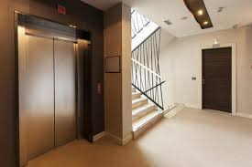

Please note that the internal and external communal parts of apartment blocks are the responsibility of the management company. Issues such as faulty lighting, intercom problems or issues to do with cleaning maintenance etc. should be directed to them.

- Storms 

During high winds or heavy snowfalls, your home may suffer damage such as roof tiles becoming loose, fencing blown over or posts becoming loose. This is not covered under the warranty so please consult your own home insurance.

- Standard of Finish 

Every Edenstone Homes home is an individually hand built product and as such is unique. You may well notice some variation in its finish and appearance from neighbouring properties or marketing images. This is perfectly normal and to be expected.

- Water Meter 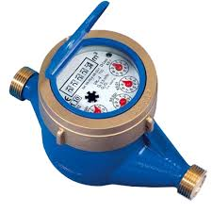

Please note that occasionally the water meter is not fitted on completion day. Please liaise closely with your water supplier so that you are aware when they fit your meter and that you have the correct readings for billing purposes.

- Maintenance of Fitted Flooring 

Regularly sweep designer flooring but avoid steam mops and vacuum cleaners as they can cause fine scratches. Use entrance mats to protect against grit and moisture. Try to avoid sliding or dragging furniture to prevent scratching and use load bearing castors to protect against damage from heavy furniture.

Clean up spills straight away and follow the manufacturer’s recommendations for regular cleaning to ensure your floor does not become too heavily soiled.

- Contact Numbers 

Should you have any further problems, please do not hesitate to contact our Customer Care Department at:

Edenstone Homes
1st Floor
Building 102
Wales One Business Park
Magor
NP26 3DG

Telephone: 01291 674800 (Monday to Friday 09:00 to 17:00)

Email: customercare@edenstonegroup.com

Web Address: www.edenstonehomes.com

Our emergency out of hours service is available on 0121 695 1032 (17:00 to 08:30 Monday to Friday, all day Saturday, Sunday and Bank Holidays).

This is strictly for emergency issues as follows:
- Central heating and hot water system – no hot water or heating as a result of a breakdown, leak or failure.
- Plumbing – Toilets not flushing, leaks from toilet, hot and cold water cylinders and tanks and central heating water pipes, if the leak can not be contained and is causing damage to the property or penetrating electrical fittings.
- Drainage – Blockages or damage to waste pipes. Blocked bath, sink, toilet or external drainage.
- Failure of internal electrics- failure of all sockets or lighting on one or more floors.
- Security – Faulty front or back door lock or if your property is not secure.

For further information please refer to your NHBC or LABC pack.

January 2019

- First Two Years at a Glance 

Common Service Items | Coverage | Comments
Appliances | YES | Manufacturer’s 2-year warranty. Remember to complete and send off all warranties and guarantees for all appliances as quickly as possible.
Bricks and Mortar | YES | Minor cracks and efflorescence are normal and can be expected.
Carpets | See comments | 2-Year warranty if fitted by Edenstone Homes. Note: normal wear and tear is not covered.
Central Heating and Boiler | YES | Manufactures 2-year warranty providing boiler has been serviced.
Central Heating and Boiler Service | NO | Home owners responsibility to be completed annually
Chips and scratches to kitchen units, appliances, glass and sanitary wear | NO | These should have been identified on the New Home Demonstration and Key Release and at the latest, 7 days after moving in
Colour variations of wood/fitted furniture and marble etc. | NO | Colour and tone variations in natural material are to be expected
Condensation | NO | This is normal during the first year
Cracks – concrete floor and blockwork | NO | Cracks are normal due to shrinkage and are to be expected
Cracks – plaster walls and finishings | NO | Cracks are normal due to shrinkage and are to be expected
Cracks – interior paint | NO | Maintenance and touch ups are the home owners responsibility
Driveways | YES | Normal Wear and tear are not covered, such as marks from power steering
Doors and lock faults | YES | During 2-year warranty. Maintenance is the homeowner’s responsibility
Doors and trim | NO | Warping which does not affect the function is normal
Electrical installation | YES | 2-year warranty, as long as not amended
Extractors and vents | YES | If due to improper installation or fault
Fencing | NO | Maintenance and care are the homeowner’s responsibility
Internal and External timber | NO | Separation, shrinkage and warping are all normal
Landscaping, paths and patio area | NO | Maintenance and care are the homeowner’s responsibility
Meters and utility lines | NO | Contact your service supplier direct
Plumbing and Drainage | YES | Stoppage due to foreign materials are the homeowner’s responsibility
Plumbing (pipe) leaks | YES | During 2-year warranty
Roof leaks | YES | During 2-year warranty. Note: third party damage caused by installation, repair or poor maintenance is not covered.
Shower and bath leaks due to grout/mastic cracks | NO | As this is due to shrinkage, we can not be held responsible for any flooring affected by this. However, we will attend to reseal if required
Storm Damage | NO | Refer to your own home insurance policy
Structure, load bearing | YES | During 2-year warranty
Window frames | YES | During 2-year warranty

